


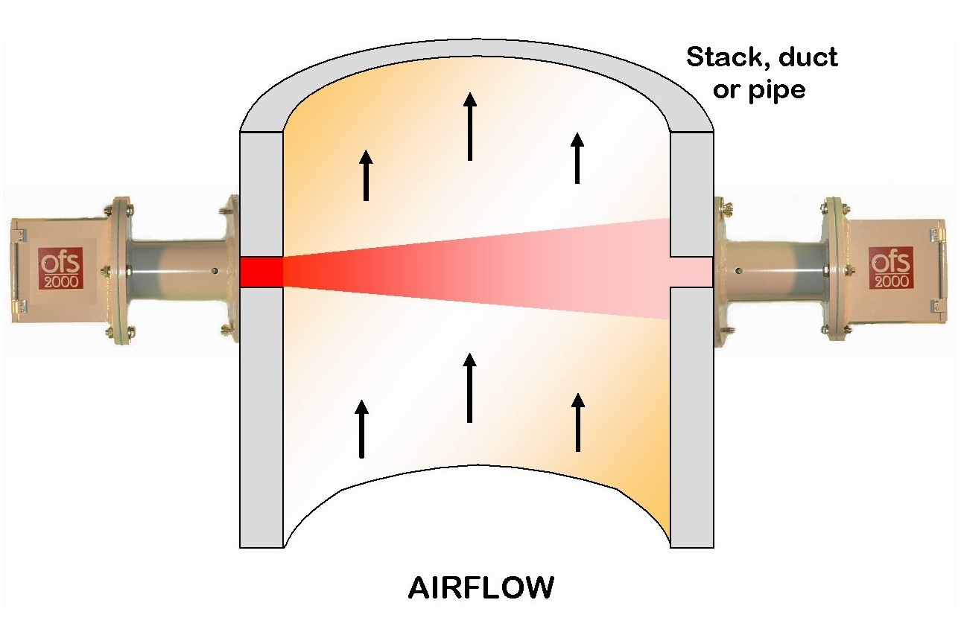
OFS-2000^{tm} Emissions/Air Flow Sensor
OFS-2000TM Advantages
- Cross stack/duct/pipe line measurement for more accurate flow readings.
- Measurement path 90° to stack; second plat-form not required – save $100K or more
- Easily replaces existing ultrasonic sensors.
- Non-interfering; nothing in flow path.
- Easy installation and optical alignment.
- Minimal upstream/downstream diameters; typically 2 & 1, not 20 & 10 like others.
- Long-term reliability: no blowers or moving parts; operates unattended - 24 / 7 / 365.
- Ultra low maintenance design.
- Rugged; designed for harsh environments.
- Built in continuous self-test diagnostics.
- Measurement unaffected by path length & media pressure, moisture & opacity.
- No flow media high temperature limits.
- Compliant with EPA 40CFR Parts 60 & 75.
- Wide versatility, NIST tested and unbeatable combination of advanced technology, high performance and proven reliability!
OFS-2000^{tm} Options:
  - Order Z-Purge Option for Class I Div I/II applications.
  - Standard Control Unit is rack mount; for wall mount, order 1910-301, NEMA4 Option.
  - For custom receiver cable length, order 1910-216-nnn where “nnn” is cable length in feet (max 300).
OFS-2000^{tm} Accessories:
- 1910-431-nn Sight Glass w/ gaskets for media isolation (2 required, multiple models)
- 1910-420 Cast Iron Gate Valves for high temperature applications (2 required)
- 1910-804 Laptop DB9 serial communications cable

OSi's patented Optical Flow Sensor (OFS) makes drift-free measurements across the entire stack, duct or pipe diameter and calculates an accurate average flow reading. It is the only flow sensor that gives a true non-contacting cross-stack flow measurement of the process. The OFS uses our EPA Method 14 approved optical scintillation technology. The optical scintillation technique relies on advanced Digital Signal Processing (DSP) electronics to "see" and measure the movement of turbulence found in a gaseous flow stream to provide highly accurate, path-averaged air velocity measurements. The accuracy of the OFS has been proven both in NIST’s wind tunnel and in numerous real-world installations.

The OFS consists of DSP / multiprocessor - based control unit teamed with a set of optical transmit and receive heads which are easily installed on opposite sides of a stack, duct, vent or pipe. The OFS heads mount fully outside of the media volume behind optical windows for easy access, more accurate measurements, and greater durability. The transmit head sends a visible diverging light beam (easy to align and vibration resistant) directly across and perpendicular to the flow (although existing angled-path port can be used). The control unit processes the fluctuations seen by the receive head and displays the flow data locally and transmits it to a PC, PLC, DAS or other data collection device that accepts a serial data link and / or a 4-20 mA current loop. The control unit can be configured from either the local keypad and display, or from a laptop or portable terminal.
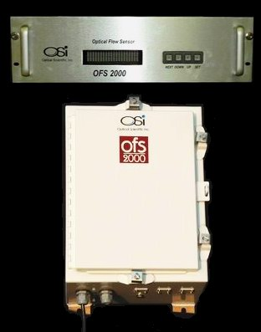

Rack mount (standard) or optional
NEMA4 Control Units shown >>>

OFS-2000^{tm} Specifications

Flow Performance
Measurement Technique | Optical Scintillation (OSi Patented)
Dynamic Range | 0.1 to 40 m/sec
Accuracy (absolute) | +/- 0.1 m/sec basic -or- +/- 2% of reading, whichever is greater
Repeatability (relative) | +/- 0.1 m/sec basic -or- +/- 1% of reading, whichever is greater
Long Term Drift | Less than 1% per year
Response Time | 3 to 600 seconds, user selectable
Automatic Calibration | 2 or 3 point; user selectable interval -or- on external command
Sensor Health Monitoring | Continuous self-test of voltages, performance, optics, etc.

Media / Environmental
Stack / Duct / Pipe Diameter | 0.3 to 10 m, standard -- consult factory for other ranges
Media Temperature / Pressure / Humidity | No effect on measurement
Media Transparency | Up to 95% opacity (OFS-2000-W is recommended for high opacity)
Ambient Temperature / Humidity | -50 to 60 C (-58 to 140 F) / 0 - 100% condensing

Physical Specifications
Light Source | Eye-safe 670 nm visible red LED, 5 deg. divergence angle
Sensor Heads (w/ 4” sch.40 flange extender) | 9 x 9 x 13 inches, 13 lbs. -- NEMA4 weather resistant
Control Unit: Rack Mount Version (standard)  NEMA4 Wall Mount (optional) | 5 x 17 x 20 inches, 13 lbs. (for indoor use) -or-  12 x 16 x 10 inches, 15 lbs. (for outdoor / factory floor use)
Purge Air for Heads | Normally not needed. 1-2 CFM max for some very dirty applications

Electrical Specification
User Interface | RS-232 serial I/O and / or 4-20 mA optically isolated current loop;  Also two sets of relay contacts for fault and calibration indication.
Power for Transmit Head | Universal 100-240 VAC, 50/60 Hz, 12 VA (fused & surge protection)
Power for Control Unit | Universal 100-240 VAC, 50/60 Hz, 40 VA (fused & surge protection)
Cable between Control Unit & Receive Head | 15 foot standard; to 300 foot optional (shielded, 10 cond., 22 AWG)

[Specifications are subject to change without notice.]
For the world’s best per-forming and most reliable advanced optical instru-ments, contact OSi today!

OSi is ISO-9001 Certified!
2 Metropolitan Ct., Suite 6
Gaithersburg, MD 20878 USA
Ph. 301-963-3630

Fax 301-948-4674
website: www.opticalscientific.com
email: sales@opticalscientific.com

